SOFTWARE ENGINEERING PROJECT

**TITLE: FindMe**

TEAM - 1

1. Chiranthan Mirle - 1001011399
2. Abhishek Agarwal - 1000987331
3. Ranjith M A - 1000969864
4. Ather Mohammed - 1000993284
5. Bhavana Nandyala - 1000859140

**Vision:** To build an interactive, user friendly, new generation search assistant which helps us to find people and places through a single touch (Most accurate for outdoors).

**Key Features:**

1. Where am I? : Shows the buildings around you, how far they are and in which direction.
2. Find me: Lets your friend find you using his phone. He will know where you are and how far you are.

**Cases/Stories:**

1. A person is lost in the campus and he wants to find out where he is. FindMe app helps him to find his location by displaying the building’s names around him and their distance and direction.
2. Person A wants to meet person B. FindMe app helps person A to pinpoint the location of Person B, even if he’s moving, through his phone. FindMe app also displays the distance between two persons.

Note:-

* If the user is indoor where the GPS is not reliable, we prompt him with the warning showing the accuracy of GPS is more than 5m, i.e., the data is imprecise, which helps him /her to be careful.
* IN each conversation a person will request and the other person acknowledges and authorizes.

**Screenshots:**

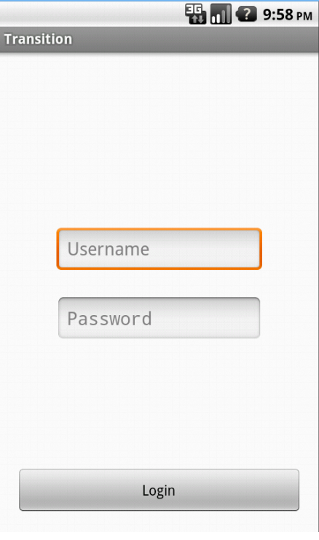

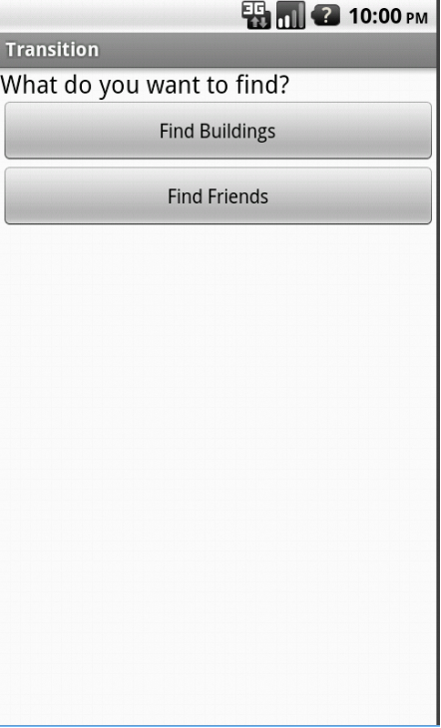

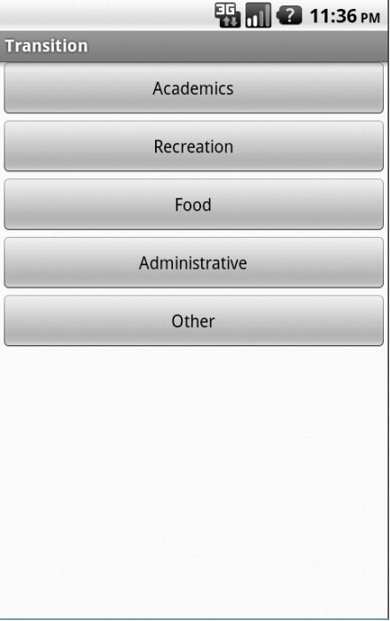

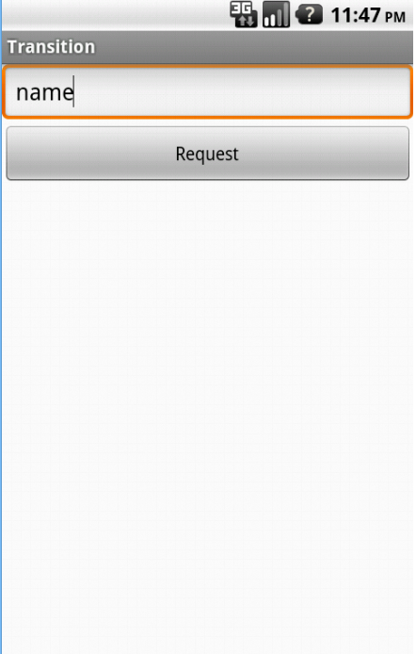

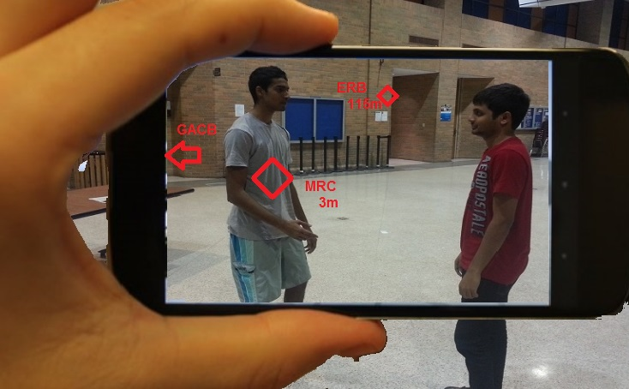

* MRC: The person whom you want to find.
* GACB and ERB: Buildings close by.
* Distance is displayed for the elements which are in the scope of the camera.

**Flowchart**

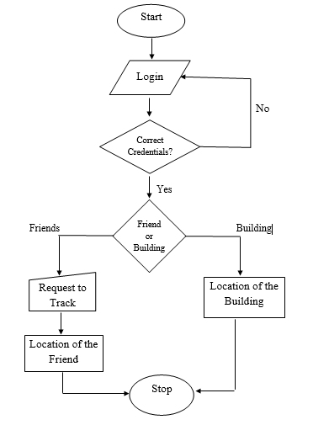

**USE CASE MODEL**

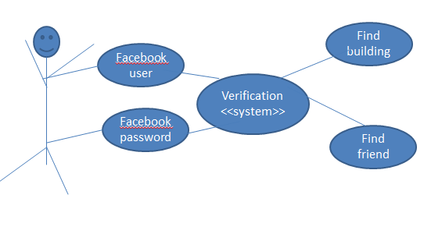

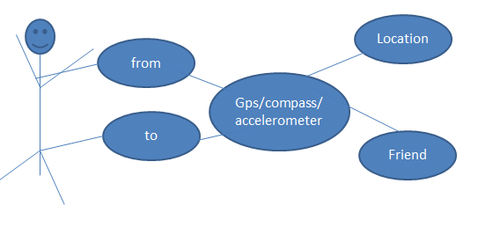

**Application Inputs:**

* User : User’s Credentials(Username and Password)
* Device : Data from the sensors( Compass, Accelerometer and GPS)

**Application Outputs:**

For the user, in the camera view,

* Markers pointing to the friend/ nearest buildings that are in the scope of camera
* Arrows pointing to the friend/ nearest buildings that are **not** in the scope of camera.

Application interacts with Satellite for GPS data and Omega server for the database (especially to authenticate users)

**Data Structures:**

We will create a database table on omega server that contains for each user the user's name, password and email address.

**Frame Work:**

1. ADT(Android development tools)
2. Eclipse
3. Google Maps API
4. Location & Sensors API for Android
5. Oracle Database.
6. GitHub

**Top Competitors:**

1. AcrossAir.
2. Find My Friends.
3. Facebook Friends Locator.
4. Layar.
5. iLoci2

**How’s FindMe better:**

1. FindMe brings in features of Compass, Gyroscope and GPS to let the user know a building/friend whom he is searching for through his camera pointing exactly (with an error correction of 2mt) to it/him without any undesired information.
2. FindMe makes it real by embedding the arrows and symbols right on to the building/person in a camera view.

**Risks:**

1. Security.
2. There can be more than one person using the same username or an imposter.
3. Application doesn’t provide accurate readings inside the building.
4. It is highly dependable on Global Positioning system (GPS).

**How do we address the risks to mitigate them?**

1. Create a login page, where a student has to enter his/her credentials to use this app.
2. In order to address the multiple names issue, we will generate the passcode.
3. In advanced devices, sensors are more accurate; so the app will exactly point to the right person.
4. Through iterative debugging the app can be brought close to perfection.

**First Iteration Plan:**

1. Designing Signup & login pages.
2. Retrieving data from the sensors.
3. Designing pages for the applications.

ITERATION -1

**ITERATION OVERVIEW**

|  |  |  |  |  |  |
| --- | --- | --- | --- | --- | --- |
| **ID** | **Description** | **Category** | **Priority** | **Iteration** | **Status** |
| FM01 | Face book authentication | Functional Requirement | 1 | 1 |  |
| FM02 | Homepage | Functional Requirement |  | 1 |  |
| FM03 | Find friend or building page | Functional Requirement |  | 1 |  |
| FM04 | Select find friend page | Functional Requirement |  |  |  |
| FM05 | Search friend page | Functional Requirement |  |  |  |
| FM06 | Authenticate using code | Functional Requirement |  |  |  |
| FM07 | Get GPS and Compass values | Functional Requirement | 1 | 1 |  |
| FM08 | Select find building page | Functional Requirement |  |  |  |
| FM09 | Select building page | Functional Requirement |  |  |  |
| FM10 | Proper navigation between pages | Reliability Requirement |  |  |  |
| FM11 | Database connectivity | Functional Requirement |  |  |  |
| FM12 | Time required to execute database operations | Performance Requirement |  |  |  |
| FM13 | Application memory usage | Performance Requirement |  |  |  |
| FM14 | UTA students with android phones | Implementation |  | 1 |  |
| FM15 | Desktops/Laptops | Implementation |  | 1 |  |
| FM16 | Eclipse | Implementation |  | 1 |  |
| FM17 | Omega server | Implementation |  | 1 |  |
| FM18 | Java | Implementation |  | 1 |  |

**RETRIEVING DATA FROM THE SENSORS**:-

**SENSORS**:-

1. Accelerometer (TYPE_ACCELEROMETER):-

Accelerometers detect acceleration forces along a single axis, three are often combined to provide acceleration detection along the x, y and z axis. Accelerometer can determine which way is down.

1. Orientation-Compass (TYPE_ORIENTATION)

Shows the direction of a Building/ Friend

1. GPS:-

Global Positioning System is a satellite service that is utilised to determine the location of a device. This will be covered further in a later tutorial.

**PARAMETERS (To Find)**:-

1. Accelerometer: X- Axis, Y- Axis, Z- Axis
2. Compass: Azimuth (Degree)
3. GPS: Latitude and Longitude

**STEPS INVOLVED IN RETRIEVING THE DATA FROM THE SENSORS**:-

1. **Obtain a Sensor Manager/ Location Manager.**

SensorManager sMan = (SensorManager) getSystemService(Context.SENSOR_SERVICE);

mlocManager = (LocationManager)getSystemService(Context.LOCATION_SERVICE);

1. **Register a Sensor Event listener/ Location listener for each of the above sensor types.**

sMan.registerListener(magnetListener, magnetField, SensorManager.SENSOR_DELAY_NORMAL);

mlocManager.requestLocationUpdates(LocationManager.GPS_PROVIDER, 0,0, mlocListener);

1. **Implement SensorEventListener/LocationListener class.**
2. SensorEventListener magnetListener = new SensorEventListener(){

public void onAccuracyChanged(Sensor sensor, int accuracy) {

// do things if you're interested in accuracy changes

}

public void onSensorChanged(SensorEvent event) {

// implement what you want to do here

} };

1. mlocListener = new LocationListener(){

public void onLocationChanged(Location loc) {}

};

FACEBOOK AUTHENTICATION:

1.       Install the prerequisites(Eclipse, Android Sdk , ADT)

2.       Install facebook sdk for android and facebook apk

3.       Import sdk into eclipse

4.       Run the samples

5.       Create a new android project with facebook login

1.       We need to install Eclipse, Android Sdk from android developers site and also install the android development tool plugins.

2.       Download and install facebook sdk which uses facebook native application to support authentication.

3.       The facebook sdk installation folder contains directory called facebook which consists of sample projects which can be imported.

4.       We create an android project with facebook login just like any other android project we need to register the package with facebook and link to the sdk project.​